Brian F. Tankersley, CPA.CITP
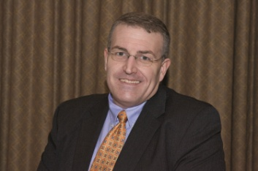
Director of Strategic Relationships, K2 Enterprises
Farragut, Tennessee
brian@k2e.com
Brian Tankersley is a consultant who advises US firms and companies on accounting technology issues. Mr. Tankersley is a frequent speaker at continuing education courses for K2 Enterprises, and publishes a nationally recognized blog on accounting and technology (www.cpatechblog.com). He has also served as the technology editor for a major accounting industry publication. Mr. Tankersley has over 20 years of professional experience, including accounting, auditing, technology, and education, and has been with K2 Enterprises since 2005.
Tankersley has been recognized seven times as one of the “Top 25 Thought Leaders in Public Accounting Technology” by Cygnus Business Media. Tankersley is also one of the authors of the Accounting Firm Operations and Technology Survey, which has been published annually for the last three years. Brian has made presentations in 46 of the 50 US states and has served as a guest speaker for many professional accounting organizations across Canada. He received the Outstanding Discussion Leader Award from the Tennessee Society of CPAs in 2009 and 2013, and was recognized for writing the Article of the Year for the Tennessee CPA Journal in 2011. Brian has presented sessions at many national conferences, including AICPA TECH+/Practitioners Conference, The Sleeter Group’s Solutions Conference, Sage Insights, CCH Connections, and Thomson Reuters Synergy User Conference.
Brian is a certified public accountant (Tennessee), a certified information technology professional (CITP), and a Chartered Global Management Accountant (CGMA). He holds bachelor’s degrees in both Accounting and Finance, cum laude, from the University of Tennessee. Tankersley also maintains numerous vendor software certifications, and is a member of the Tennessee Society of CPAs and the American Institute of CPAs.
Brian and his family make their home in Farragut, Tennessee.

