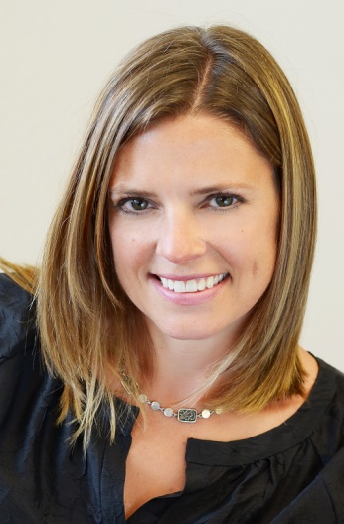
Carrie Steffen
President
Phone: 319.447.6402
carrie@thewhetstonegroup.com

Carrie is a founding shareholder and President of The Whetstone Group, Inc. Since 2000 Whetstone has provided growth consulting services to hundreds of CPA firms, professional service firms, and companies in business-to-business markets nationwide. She has nearly 20 years of professional services marketing experience.

Carrie helps clients:
- Determine how to best organize for growth and build a sustainable growth culture.
- Develop comprehensive growth plans, providing ongoing support and consultation.
- Establish accountability for business development and meet their revenue goals.
- Implement follow-up strategies to help manage the sales process with prospective clients and maximize their ROI on marketing.

She is also a skilled trainer and provides group sales training as well as one-on-one coaching that enables attendees to better understand the sales cycle and develop the personal skills necessary to close sales. Firm leaders, practitioners, marketing professionals benefit from her knowledge and dynamic approach.

Before joining Whetstone, Carrie was an in-house marketing director in the national marketing office of RSM McGladrey, Inc.

Speaking/Writing
Carrie has presented for the AICPA, the Association for Accounting Marketing’s (AAM) Annual Summit, the Indiana CPA Society, DFK USA’s Annual Growth Summit, Moore Stephens North America, MSI Global Alliance’s International Managing Partner Conference, BKR’s Annual Marketing Meeting, PKF North America and The International Group of Accounting Firms (IGAF). She has been published in the AAM’s MarkeTrends, The Journal of Accounting Marketing and the CPA Practice Management Forum.

Leadership
Carrie is also a member of the CPA Consultants’ Alliance (CPACA), a working group of thought leaders united in their efforts to further leadership within the CPA profession. Through collaboration, the CPACA offers deliverables and solutions CPA firms can use to advance leadership in their firm. She has also served on the AAM’s Board of Directors as well as Chair of AAM’s Education Committee.

