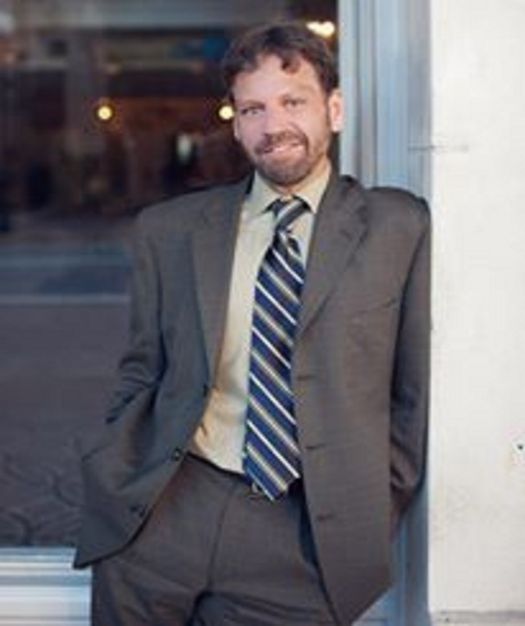

Craig W. Smalley, EA, has been admitted to practice before the Internal Revenue Service as an Enrolled Agent, has a Certificate in Taxation from UCLA, is a Certified Tax Resolution Specialist, and is a Certified Estate Planner. He has been in practice since 1994. He is the CEO and Founder of CWSEAPA®, PLLC, Tax Crisis Center®, LLC, and Cannabis Accounting Group®. All three companies have offices in Florida, but Craig has clients all over the country. He has been published in the New York Times, Chicago Tribune, NASDAQ, Yahoo Finance, Christian Science Monitor, and is a Columnist for accounting trade journals Accounting Web, and CPA Practice Advisor. He has also contributed to Ganjaprenuer., CPA Trendlines, and EA Journal. He has done several Public Speaking Engagements. He specializes in taxation, and is well versed on U.S. Tax Court rulings. Finally, Craig has appeared as a guest on countless radio shows and podcasts. He can be reached at craig@cwseapa.com

