Eric Majchrzak
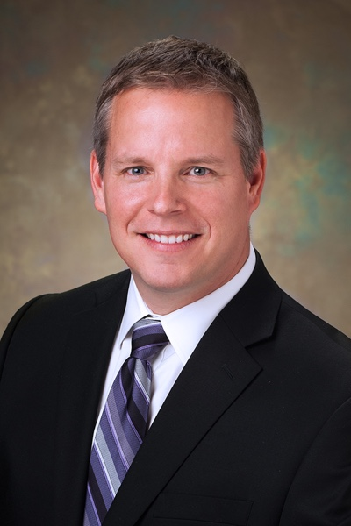
Eric Majchrzak is a shareholder and chief marketing officer of BeachFleischman PC. He joined BeachFleischman in 2012 and is responsible for the firm’s overall marketing initiatives, including institutional firm branding, innovation, service line development, client satisfaction, firm growth initiatives, niche marketing and digital marketing. He is a nationally renowned professional services marketer and has 25 years of executive marketing and business development experience. He has been acknowledged as one of the accounting profession’s pioneers in digital marketing and social media and has helped, through transparency of his own practices, to guide the profession towards progressive marketing strategies.
In 2015, he won the prestigious “Marketer of the Year” award, presented by Inside Public Accounting at the Association for Accounting Marketing’s Annual Summit and AICPA Practitioners Symposium & Tech Plus conference in Orlando, FL. In 2011 and 2010, he was named by the editorial team of Accounting Today magazine as one of the “Top 100 Most Influential People” in the accounting profession. He was acknowledged alongside others making an impact on the profession, including: regulators, agency heads, congressional leaders, consultants and top CEOs. Eric is a past two-term board member-at-large of the Association for Accounting Marketing. He is an Advisory Board member with Thomson Reuters’ Checkpoint Marketing For Firms. He is an instructor at the Accounting Today Institute and a contributing blogger/author for Intuit’s Accountants Blog. He is also a faculty member of iShade, the nation’s leading online community for accountants and a faculty member of the 2013 Hildebrandt Institute/Thomson Reuters Social Media for Law Firms Conference.
He was previously the Director of Marketing for Freed Maxick CPAs (a Top 100 Largest Firm in the U.S.) and through Freed’s alternative practice structure with RSM McGladrey, he was one of RSM McGladrey’s Great Lakes regional marketing directors.

