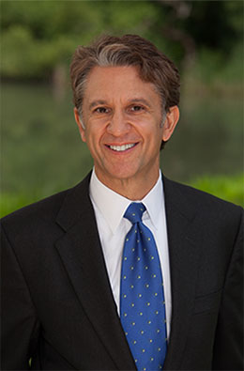

Rick Lazio
Rick Lazio is currently a Partner in the New Orleans based law firm Jones Walker, with 17 offices throughout the United States. In addition to heading their New York office, he oversees their National Housing Finance Practice group, with focus on issues of affordable housing, housing finance, as well as financial services.
Mr. Lazio is also a Director of Houston, Texas based alliantgroup. The national tax-consulting firm specializes in qualifying businesses for state and federal tax credits, incentives and deductions.
He served in the United States House of Representatives for four terms. Elected to the United States Congress to represent New York’s 2nd Congressional District after defeating an 18-year incumbent, he became Deputy Majority Whip and was later named Assistant Majority Leader in the United States House of Representatives. As Chairman of the House Financial Services Committee’s Subcommittee on Housing and Community Opportunity, Mr. Lazio was the author of several important laws, including the Quality Housing and Work Responsibility Act of 1998 and the Native American Housing Assistance and Self Determination Act.
After leaving Congress in 2001, he became the President and Chief Executive Officer of the Financial Services Forum with offices in New York and Washington, DC. The economic policy organization is comprised of CEOs of 20 of the largest financial institutions doing business in the United States.
In 2004, Mr. Lazio joined JPMorgan Chase as Executive Vice President of Global Government Affairs and Public Policy and as a member of the firm’s Executive Committee. In this role, he and his team provided strategic advice and intelligence to senior management on the impact of public policy on the firm’s businesses and clients, and managed the firm’s wide ranging environmental initiatives – including the bank’s response to climate change.
He was subsequently named Managing Director, JP Morgan Asset Management, Global Real Estate and Infrastructure.
Prior to serving in Congress, Mr. Lazio served as an Assistant District Attorney in Suffolk County, New York, founded a law firm and was a member of the Suffolk County Legislature.
Currently, he sits as a board member of numerous national civic and philanthropic organizations including Enterprise Community Partners, the Bretton Woods Committee, World Rehabilitation Fund and the International Conservation Caucus Foundation.
Mr. Lazio is a graduate of Vassar College, where he is a member of the President’s Advisory Committee, and Washington College of Law of American University, where he is on the Dean’s Advisory Committee.

